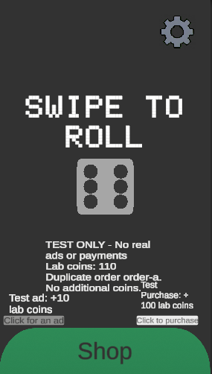
Test 1: Completed ad and purchase complete
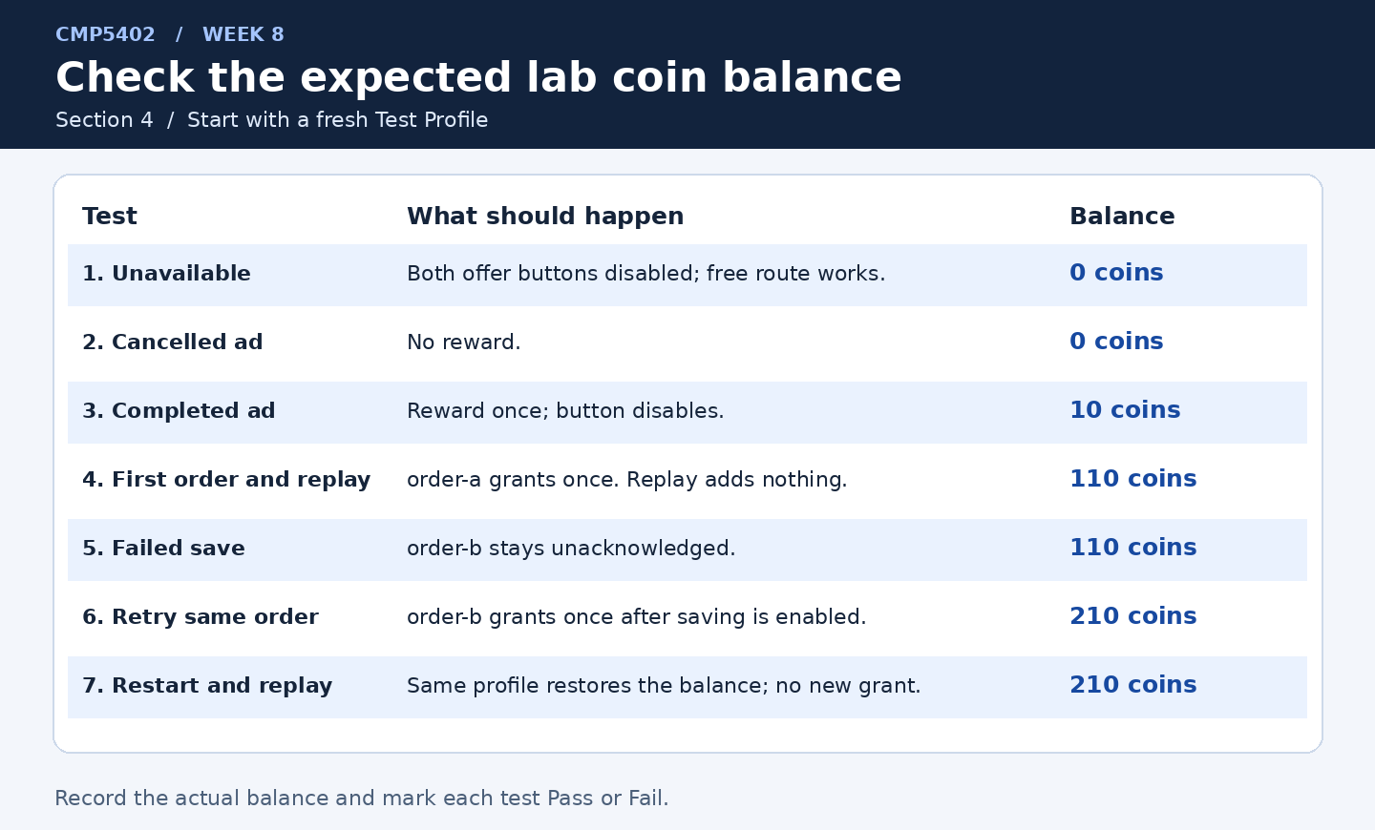
My outcomes all came out as expected based on this table provided in the lab.

Monetisation plan:
I plan on having rewarded ads for things such as double dots for a minute or double coins at the end of the next round. And then time-based ads every 5-7.5 minutes which resets if the player watches a reward ad. There will then be one, one time purchase for disabling ads. Players will have free access to rewarded ads without watching the ads.
I would avoid selling cosmetics and game skips as I feel both are unnecessary for my game.
The cosmetics especially I want to be things players earn through progressing through the game not purchasing as different dice cosmetics will come with in game buffs and negatives.

